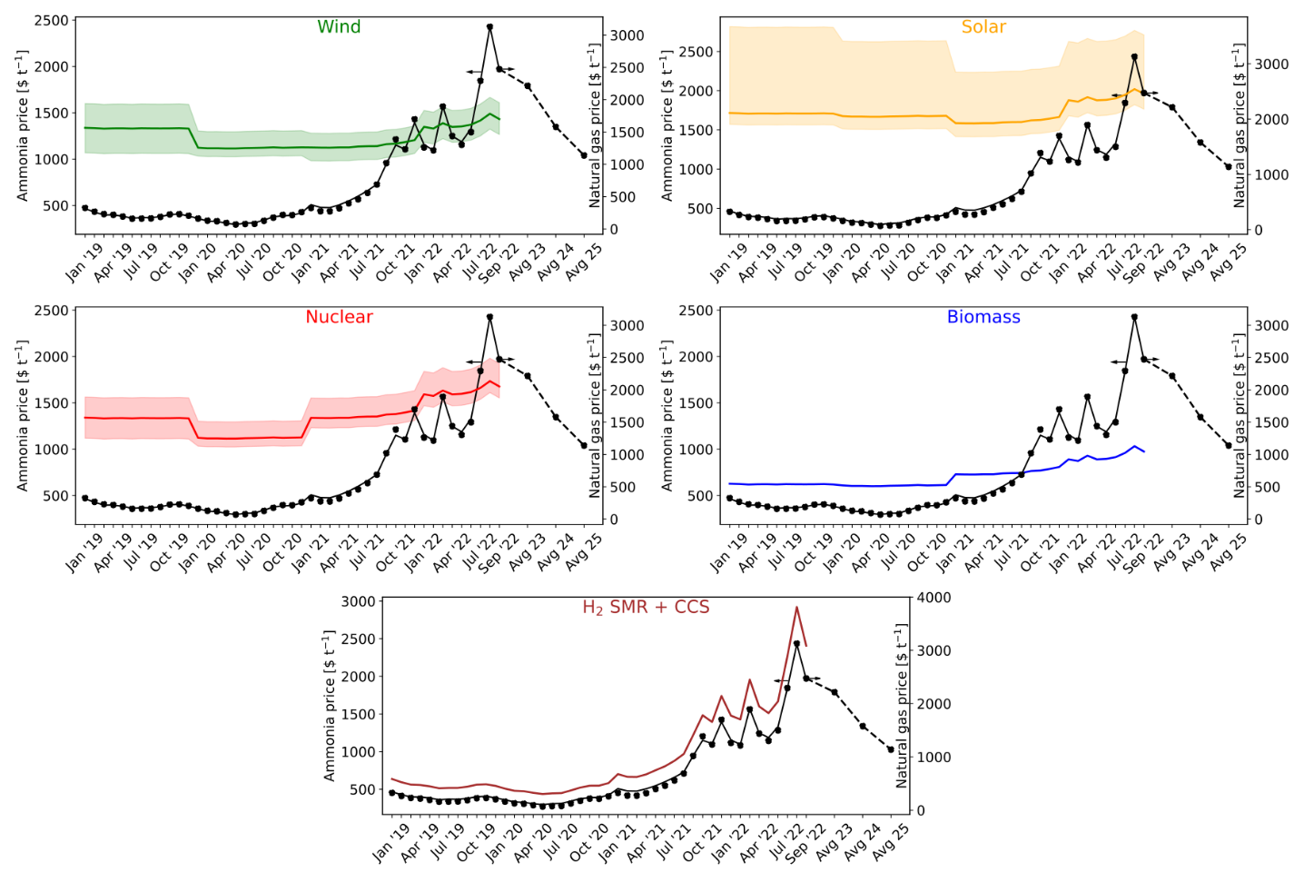
Caption: BAU ammonia v green ammonia at current natural gas prices with hydrogen from (a) water electrolysis using on-shore wind electricity, (b) water electrolysis using solar electricity, (c) water electrolysis using nuclear electricity, (d) biomass gasification, and (e) SMR + CCS.
Methods:
- Material and energy flows for both BAU ammonia and green ammonia are taken from Sebastiano et al., 2021.
- Monthly average natural gas prices are taken from https://www.statista.com/statistics/673333/monthly-prices-for-natural-gas-in-the-united-states-and-europe/.
- Monthly average electricity prices are taken from https://www.statista.com/statistics/1267500/eu-monthly-wholesale-electricity-price-country/.
- Average natural gas prices for the year 2023, 2024, and 2025 are calculated using the monthly average estimates extracted from https://www.cmegroup.com/markets/energy/natural-gas/dutch-ttf-natural-gas-calendar-month.quotes.html.
- Average electricity prices for the year 2023, 2024, and 2025 are calculated assuming a similar electricity mix as 2021 and adjusting it depending on the contribution of natural gas in the electricity mix.
- For BAU ammonia, we consider the case of SMR with CCS from the syngas only.
- Using these prices of natural gas and electricity mix, the cost of production for BAU ammonia is calculated. The contribution from CAPEX, feedstock excluding natural gas, and utilities other than electricity are extracted from Sebastiano et al., 2021 and adjusted for inflation using the average CEPCI index for the respective years.
- A similar method is followed for calculating the green ammonia prices.
- For the case of solar, wind, and nuclear, only the electrolyzer uses the corresponding electricity. Whereas, the production process itself uses the electricity mix for the respective year.
- For the case of solar and wind, the levelized cost of electricity and the capacity factors are extracted from IRENA for the respective years. Using this data, the levelized cost of hydrogen is calculated according to the procedure specified by Sebastiano et al., 2021.
- For nuclear, the levelized cost of electricity is extracted from Parkinson et al., 2019 and adjusted for inflation for the respective years. We assume a capacity factor of 95% for this case. The levelized cost of hydrogen is then calculated similarly as mentioned previously.
- For the biomass scenario, the levelized cost of hydrogen is extracted from Parkinson et al., 2019 and then adjusted for inflation.
- For the case of hydrogen from SMR + CCS, the data is extracted from Guido Collodi et al., 2016 and recalculated for the respective natural gas and electricity prices from the references mentioned in points 2 to 5.
- Difference between BAU ammonia and ammonia from hydrogen using SMR + CCS is that for the former case, we do not need nitrogen feed as we use an autothermal reactor for the production of syngas. However, for the case of hydrogen from SMR + CCS, we need additional nitrogen feed.
- Also, in the BAU ammonia case, the production of hydrogen and ammonia are integrated into one process which reduces the energy consumption due to heat integration. Whereas, for the case of hydrogen from SMR + CCS, the production of hydrogen and ammonia are two different processes.
Discussions:
- The shaded area for all the cases (if present), represent the sensitivity analysis of the levelized cost of electricity prices extracted from IRENA.
- In the current scenario, ammonia with hydrogen from wind electrolysis is economically cost competitive compared to BAU ammonia.
- However, in the case of solar energy, green ammonia is not very cost competitive in comparison to BAU ammonia. This can be attributed to lower capacity factors which result in higher levelized costs of electricity.
- Similarly, nuclear energy is feasible in the current scenario as it has a higher capacity factor of around 95%. However, the disposal of spent fuels and the increasing cost of production of electricity is a major concern for this technology.
- The best performing route economically is the biomass route. Here the biomass route refers to the production of hydrogen from biomass with carbon capture and storage.
- The worst performing route is the H₂ from SMR + CCS scenario. It is the only scenario in our study which is worse than the BAU ammonia as the process itself is not integrated into one whole and requires higher energy. Also, nitrogen input is required in the H₂ from SMR + CCS route for ammonia production whereas, for BAU ammonia, nitrogen comes from air required in the autothermal reformer.
- The BAU route uses 0.53 kg of natural gas and 0.96 kWh of electricity per kg of ammonia produced.
- For the green routes of ammonia production, excluding the biomass scenario, the electrolyzer is powered using the corresponding renewable power. However, the production process itself uses grid electricity. Therefore, all the green routes use 0.47 kWh of grid electricity per kg of ammonia produced.
- For the case of H₂ from SMR + CCS, per kg of hydrogen produced requires 3.96 kg of natural gas. Consequently, per kg of ammonia produced requires 0.47 kWh of electricity and 0.18 kg of hydrogen from SMR + CCS.
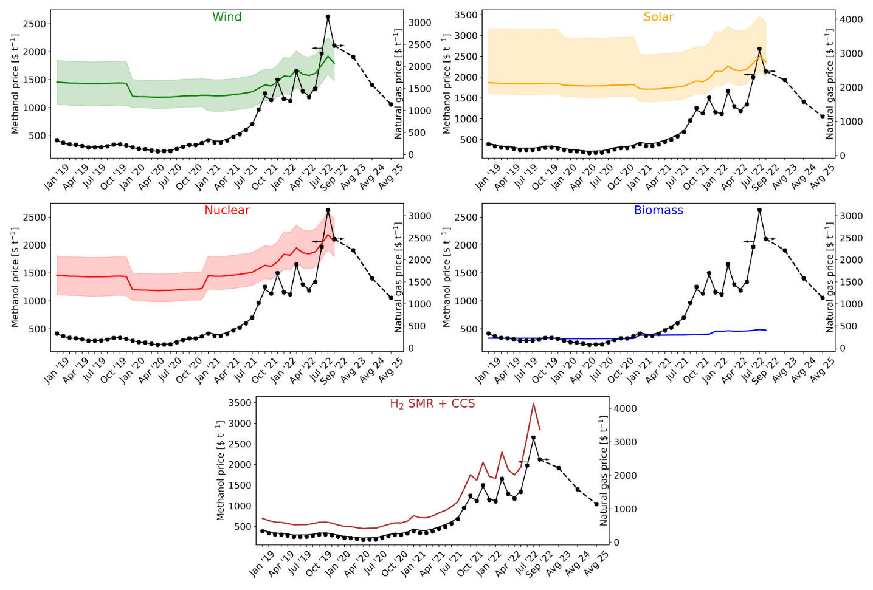
Caption: BAU methanol v green methanol at current natural gas prices with hydrogen from (a) water electrolysis using on-shore wind electricity, (b) water electrolysis using solar electricity, (c) water electrolysis using nuclear electricity, (d) biomass gasification, and (e) SMR + CCS.
Methods:
- Material and energy flows for BAU methanol are taken from L.A. Pellegrini et al., 2011 and green methanol are taken from Daniel et al., 2021.
- Monthly average natural gas prices are taken from https://www.statista.com/statistics/673333/monthly-prices-for-natural-gas-in-the-united-states-and-europe/.
- Monthly average electricity prices are taken from https://www.statista.com/statistics/1267500/eu-monthly-wholesale-electricity-price-country/.
- Average natural gas prices for the year 2023, 2024, and 2025 are calculated using the monthly average estimates extracted from https://www.cmegroup.com/markets/energy/natural-gas/dutch-ttf-natural-gas-calendar-month.quotes.html.
- Average electricity prices for the year 2023, 2024, and 2025 are calculated assuming a similar electricity mix as 2021 and adjusting it depending on the contribution of natural gas in the electricity mix.
- Using these prices of natural gas and electricity mix, the cost of production for BAU methanol is calculated. The contribution from CAPEX, feedstock excluding natural gas, and utilities other than electricity are extracted from L.A. Pellegrini et al., 2011 and adjusted for inflation using the average CEPCI index for the respective years.
- A similar method is followed for calculating the green methanol prices.
- Green methanol uses carbon dioxide from DAC, which also uses a small amount of natural gas. Therefore, using the above-mentioned natural gas price sources, the cost of carbon dioxide is recalculated and adjusted for inflation.
- For the case of solar, wind, and nuclear, only the electrolyzer uses the corresponding electricity. Whereas, the production process itself uses the electricity mix for the respective year.
- For the case of solar and wind, the levelized cost of electricity and the capacity factors are extracted from IRENA for the respective years. Using this data, the levelized cost of hydrogen is calculated according to the procedure specified by Sebastiano et al., 2021.
- For nuclear, the levelized cost of electricity is extracted from Parkinson et al., 2019 and adjusted for inflation for the respective years. We assume a capacity factor of 95% for this case. The levelized cost of hydrogen is then calculated similarly as mentioned previously.
- For the biomass scenario, the cost of production for methanol is extracted from S. Yang et al., 2018 and then adjusted for inflation.
- For the case of hydrogen from SMR + CCS, the data is extracted from Guido Collodi et al., 2016 and recalculated for the respective natural gas and electricity prices from the references mentioned in points 2 to 5.
- Difference between BAU methanol and methanol from hydrogen using SMR + CCS is that for the latter case, we use carbon dioxide and hydrogen from SMR + CCS for the production of methanol whereas, for the former case, we go directly from natural gas to methanol via syngas.
Discussions:
- The shaded area for all the cases (if present), represent the sensitivity analysis of the levelized cost of electricity prices extracted from IRENA.
- In the current scenario, methanol with hydrogen from wind electrolysis is economically cost competitive compared to BAU methanol.
- However, in the case of solar energy, green methanol is not cost competitive in comparison to BAU methanol. This can be attributed to lower capacity factors which result in higher levelized costs of electricity.
- Similarly, nuclear energy is feasible in the current scenario as it has a higher capacity factor of around 95%. However, the disposal of spent fuels and the increasing cost of production of electricity is a major concern for this technology.
- The best performing route economically is the biomass route. Here the biomass route refers to the production of methanol from biomass.
- The worst performing route is the H₂ from SMR + CCS scenario. It is the only scenario in our study which is worse than the BAU methanol. This process uses carbon dioxide from DAC and hydrogen from SMR + CCS for the production of methanol. Whereas, in the BAU route we go from natural gas to methanol directly via syngas.
- The BAU route uses 0.67 kg of natural gas and 0.71 kWh of electricity per kg of methanol produced.
- For the green routes of methanol production, excluding the biomass scenario, the electrolyzer is powered using the corresponding renewable power. However, the production process itself uses grid electricity. Therefore, these green routes use 0.17 kWh of grid electricity per kg of methanol produced.
- Methanol production via biomass uses 1.74 kg of biomass (straw) and 0.10 kWh of electricity per kg.
- For the case of H₂ from SMR + CCS, per kg of hydrogen produced requires 3.96 kg of natural gas. Consequently, per kg of methanol produced requires 0.17 kWh of electricity and 0.19 kg of hydrogen from SMR + CCS.
- All alternate routes except the biomass route use carbon dioxide from DAC as the feed. Carbon dioxide itself requires 0.11 kg of natural gas per kg of carbon dioxide captured. Further, one kg of methanol produced requires 1.5 kg of carbon dioxide. Therefore, the cost of carbon dioxide from DAC is also a function of the natural gas prices.

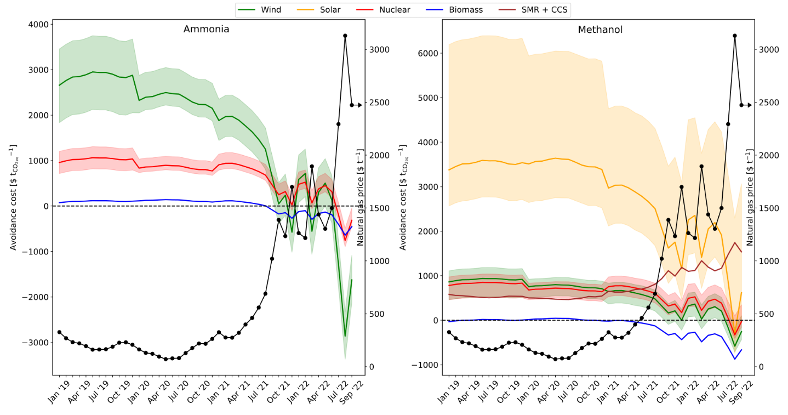
Caption: CO₂ avoidance costs v natural gas prices for (a) ammonia and (b) methanol.
Methods:
- Formula: ${ CO}_{2} avoidance costs= \frac{{P.C}_{alt} - {P.C}_{BAU}}{{GWP}_{BAU} - {GWP}_{alt}}$
  - ${CO}_{2} avoidance costs in \$ t_{{CO}_{2}eq}^{-1}$
  - $P.C is the production cost in \$ t^{-1} of product$
  - $GWP is the global warming potential in t_{{CO}_{2}eq} t^{-1} of product$
  - $alt are the alternative routes of production$
  - $BAU is the business as usual route of production$
- The GWP values are calculated using the characterization factors for the material flows obtained from SimaPro v3.0.
Discussions:
- Avoidance costs represent the amount of money we spend or save for every ton of carbon dioxide avoided in comparison to the BAU route.
- The avoidance costs follow an inverse trend to the natural gas prices. Therefore, as the natural gas prices increase, we start saving money rather than spending to avoid emissions.
- In the case of ammonia, there are no solar and H₂ from SMR + CCS plots as the GWP values of these two routes are higher than that of the BAU.
- The shaded area represents the uncertainty in the LCOE prices of different technologies.
Tables
Table 1 – Average monthly prices of natural gas and electricity
Month | NG  Price [$ t⁻¹] | Electricity  Price [$ MWh⁻¹]
Jan '19 | 326.18 | 49.41
Feb '19 | 268.54 | 42.81
Mar '19 | 231.45 | 30.61
Apr '19 | 219.83 | 36.97
May '19 | 193.92 | 37.83
Jun '19 | 160.41 | 32.50
Jul '19 | 161.75 | 39.71
Aug '19 | 164.43 | 36.82
Sep '19 | 188.11 | 35.77
Oct '19 | 226.09 | 36.95
Nov '19 | 230.11 | 41.00
Dec '19 | 206.43 | 31.97
Jan '20 | 162.20 | 34.98
Feb '20 | 130.02 | 21.91
Mar '20 | 121.53 | 22.52
Apr '20 | 94.73 | 17.05
May '20 | 70.60 | 17.60
Jun '20 | 78.19 | 26.23
Jul '20 | 80.43 | 30.07
Aug '20 | 127.79 | 34.89
Sep '20 | 176.49 | 43.68
Oct '20 | 218.49 | 33.96
Nov '20 | 216.26 | 38.80
Dec '20 | 261.84 | 43.55
Jan '21 | 324.84 | 52.79
Feb '21 | 275.24 | 48.71
Mar '21 | 273.90 | 47.18
Apr '21 | 319.48 | 53.66
May '21 | 398.12 | 53.33
Jun '21 | 460.22 | 74.13
Jul '21 | 558.97 | 81.29
Aug '21 | 689.44 | 82.81
Sep '21 | 1020.53 | 128.34
Oct '21 | 1387.37 | 139.54
Nov '21 | 1234.11 | 176.25
Dec '21 | 1699.25 | 220.96
Jan '22 | 1262.71 | 167.87
Feb '22 | 1216.69 | 128.78
Mar '22 | 1894.06 | 251.76
Apr '22 | 1438.75 | 166.00
May '22 | 1303.37 | 177.51
Jun '22 | 1499.52 | 218.18
Jul '22 | 2293.52 | 315.26
Aug '22 | 3129.51 | 469.35
Sep '22 | 2473.28 | 346.12

Table 2 – Average CEPCI indexes
Year | CEPCI
2019 | 607.5
2020 | 596.2
2021 | 708.0
2022 (average till July) | 816.1

Table 3 – Cost parameters used in economic calculations. All costs are presented in $_{2019.}
Component | Average | Low | High
Water [$ t⁻¹] | 0.18 | - | -
Cooling water [$ GJ⁻¹] | 0.38 | - | -
CO₂ capture and storage [$ t⁻¹] | 15.84 | - | -
CO₂ emissions [$ t⁻¹] | 30.00 | - | -
Nitrogen [$ t⁻¹] | 91.06 | - | -
Carbon dioxide – DAC [$ t⁻¹] * | 137.35 | 67.85 | 206.85
*These prices do not include the cost of natural gas required for the capture of carbon dioxide. 1 ton of carbon dioxide requires 0.11 ton of natural gas.
Table 4 – Levelized cost of electricity in $ MWh⁻¹ and capacity factors (CF)
 | 2019 |  |  |  | 2020
 | Average | Low | High | CF | Average | Low | High | CF
Wind - on shore | 67 | 37 | 96 | 35.6 | 45 | 35 | 65 | 36.0
Solar PV | 68 | 52 | 190 | 17.5 | 57 | 39 | 163 | 16.1
Nuclear | 87 | 63 | 112 | 95.0 | 69 | 42 | 102 | 95.0

 | 2021 |  |  |  | 2022
 | Average | Low | High | CF | Average | Low | High | CF
Wind - on shore | 42 | 26 | 59 | 39.0 | 48 | 30 | 68 | 39.0
Solar PV | 48 | 29 | 120 | 17.2 | 55 | 33 | 138 | 17.2
Nuclear | 82 | 50 | 121 | 95.0 | 94 | 57 | 140 | 95.0

Table 5 – Levelized cost of hydrogen in $ t⁻¹
 | 2019 |  |  | 2020
 | Average | Low | High | Average | Low | High
Wind - on shore | 6296 | 4761 | 7780 | 5138 | 4626 | 6162
Solar PV | 8444 | 7625 | 14688 | 8278 | 7357 | 13703
Nuclear | 6316 | 5053 | 7579 | 5138 | 4626 | 6162
Biomass with CCS | 2270 | - | - | 2228 | - | -

 | 2021 |  |  | 2022
 | Average | Low | High | Average | Low | High
Wind - on shore | 4894 | 4075 | 5764 | 5641 | 4697 | 6644
Solar PV | 7507 | 6534 | 11192 | 8653 | 7532 | 12900
Nuclear | 6102 | 5494 | 7317 | 7033 | 6333 | 8434
Biomass with CCS | 2646 | - | - | 3049 | - | -

Table 6 – Global warming potentials in kg_{CO2eq} kg⁻¹ ammonia for all scenarios
Process | GWP
BAU | 1.040
Wind | 0.712
Solar | 1.140
Nuclear | 0.126
Biomass | -1.140
H₂ SMR + CCS | 1.220

Table 7 – Global warming potentials in kg_{CO2eq} kg⁻¹ methanol for all scenarios
Process | GWP
BAU | 0.658
Wind | -0.556
Solar | 0.226
Nuclear | -0.686
Biomass | -1.790
H₂ SMR + CCS | 0.169

